Patient Information:

Name: __________________________________ Date of Birth: _____/_____/_____ Sex: (M/F)________

Address: ________________________________ Soc. Sec. # ______-_____-_____ Marital Status: _____

City: ___________________________________ State: _________________ Zip Code: _____________

Primary Phone:(_____)____________ 2ndary Phone:(______)____________ Occupation:_____________

e-mail Address: _________________________ Spouse’s Name: ________________________________

Emergency Contact: ______________________ Relationship to patient: _________________________

Emergency Contact Phone: (_____)__________ Primary Care Doctor: ___________________________

Referring Doctor: _______________________________

Klamath Pulmonary & Critical Care Medicine
David Panossian, M.D., P.C., FACP, FCCP, DABSM
2614 Almond Street, Klamath Falls, Oregon 97601
(541)-885-2201, FAX (541) 883-1400

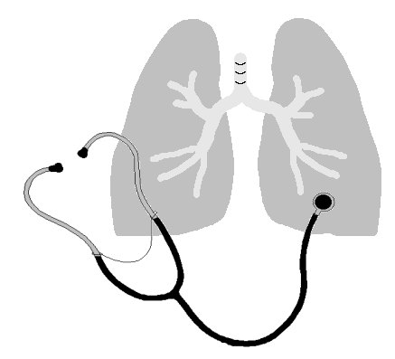
Primary Insurance: ________________________________ Insured Party’s Name: _________________

Address: _________________________________ Phone #: (_____)____________ Group#: ___________

ID & SSN #: _______________________________ Insured’s DOB: ______________________________
Secondary Insurance: ________________________________ Insured Party’s Name:________________

Address: _________________________________ Phone #: (_____)____________ Group#: ___________

ID & SSN #: ________________________________Insured’s DOB: _____________________________
Protected Health Information Release:

Can confidential messages (ie. Appointment reminders) be left on your answering machine or voice mail?
YES __________ NO __________

If you do not have voice mail, can a confidential message be left at your place of employment?
YES __________ Work Phone Number ( ) _______________ NO __________

Please print the telephone number, if any, where you want to receive calls about your appointments, lab
and x-ray results, or other health care information if other than your primary phone number.

(_______)______________________

Patient’s Signature _______________________________________________ Date ______________________

(NOTE;PLEASE TURN FORM OVER TO COMPLETE)

MEDICAL RECORDS RELEASE:
I hereby authorize my medical records to be released to another physician or myself if necessary. I consent
to release my medical information during the next 180 days from the date of signing or for the period
reasonably needed to complete any request.

________________________ ________________________________________________
DATE PATIENT’S OR RESPONSIBLE PARTY SIGNATURE

________________________ _________________________________________________
DATE PATIENT’S OR RESPONSIBLE PARTY SIGNATURE
FINANCIAL AGREEMENT:
My balance or the balance of the bill that is not paid by my insurance will be paid within 60 days of the
billing for that balance. Balances outstanding over 60 days are considered delinquent and are subject to
being sent to a collection agency. Payment arrangements need to be set up in advance with the billing
manager and scheduled monthly amounts must be received on time to maintain a current account.
I understand and will comply with this agreement.

___________________ ________________________________________________
DATE PATIENT’S OR RESPONSIBLE PARTY SIGNATURE
INSURANCE:
I consent to treatment and request payment of authorized benefits be made on my behalf to
David Panossian, MD.

I authorize any holder of medical information about me to be released to my insurance company needed to
determine benefits for related services.

If payment is made directly to me from the insurance company I will either endorse the check and send to
the doctor or write a personal check for said amount and send within five days of receipt of such a check.

I understand that I am also responsible for any balance not paid by the insurance company and this balance
is subject to the financial agreement noted and signed above.

As an OHP Provider, member forms, policies and advance directives are available.

__________________ ________________________________________________
DATE PATIENT’S OR RESPONSIBLE PARTY SIGNATURE

MEDICARE INSURED:
In order to submit a claim for payment to us for services covered under your policy, we must have your
authorization to release medical information to your insurance carrier.

I request that payment of Medicare benefits be made to David Panossian, MD, for any services provided for
me by this office.

I authorize any holder of medical information about me to be released to the health care financing
administration and its agents, any information needed to determine these benefits or the benefits payable for
related services.

________________________ ________________________________________________
DATE PATIENT’S OR RESPONSIBLE PARTY SIGNATURE

