David Panossian, M.D.
2614 Almond Street, Klamath Falls, Oregon 97601
(541) 885-2201, FAX (541) 883-1400

Klamath Pulmonary & Critical Care Medicine
Klamath Sleep Medicine Center
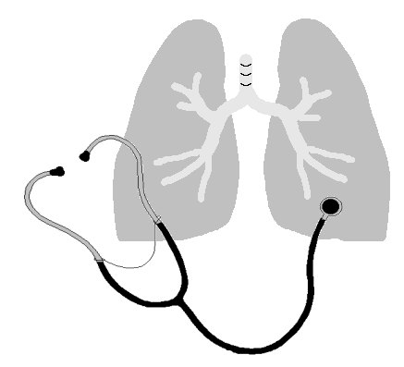


Financial Policy

Thank you for choosing us as your health care provider. The following is the terms and conditions of our Financial Policy. This Financial Policy has been developed in an effort to remove any misunderstanding that may arise regarding a patient’s account. Our main concern is that you receive the highest level of quality care and personal service. If you have any questions or concerns about our Financial Policy, please do not hesitate to contact our billing manager.

Fees and Payment Policies
(Please initial each line)

______Co-pays and co-insurance are due at the time of service.

______Self-Pay patients, payment is expected at the time of service.

______We offer CareCredit Patient Payment Plans as our primary payment plan for those patients who need to set up a payment plan. Arrangements must be made prior to appointment. CareCredit is an exceptional payment plan offering up to eighteen months with no interest (longer terms available with interest). No other payment plan will be considered unless you do not qualify for CareCredit.

______Statements are mailed monthly and are due ten days from the date of receipt.

______We will bill most primary insurance companies. All insurance policies are different and it is the responsibility of the patient not the provider or staff to know what is covered and what is not covered.

______Patients with individual insurance policies: (choose one)
______ show proof of premium paid for the current month (applies to all future visits as well)
______ sign an ACH / Credit card authorization form

______ No show fees are charged as follows: New patient - $100.00, Sleep Study - $150.00,
Follow-up office visit - $50.00. To avoid no show fees please cancel 24 hours in advance.

Thank you again for choosing us as your health care provider. We appreciate your trust in us and we appreciate the opportunity to serve you.

By signing below, I acknowledge that I have read, understand, and agree to the terms of this Financial Policy:

X__________________________________________________ Date__________________________
Signature of Patient or Responsible Party

