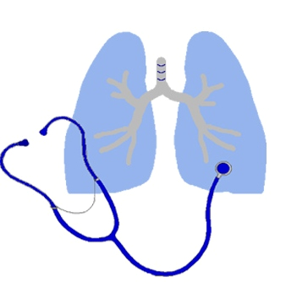
Klamath Pulmonary & Critical Care Medicine
Klamath Sleep Medicine Center

David Panossian, M.D.
2614 Almond Street, Klamath Falls, Oregon 97601
(541) 885-2201, FAX (541) 883-1400

Electronic Exchange (Carequality and Reliance) Opt-In / Opt-Out Form

_______________________________________________ _____________________
Patient Name (please print) Date of Birth

Your healthcare may be managed by David H Panossian, MD, PC and other healthcare teams (non-David H Panossian, MD, PC). We believe that fast, secure transmission of health information at the point of care can improve your care. David H Panossian MD, PC uses the following electronic exchanges to retrieve and share your health information.

- Carequality: Carequality is a public-private initiative that enables widespread operational connectivity between and among existing health IT data exchange programs and platforms. The Carequality Framework (an initiative by the Sequoia Project) creates a common legal framework, enforces standard technical specifications, and publishes a directory of participants, enabling health information exchanges to become seamless at the point of care.
- Reliance eHealth Collaborative is a health information exchange (HIE). An HIE is a system that electronically moves and exchanges patients’ (PHI) Protected Health Information between participating health care providers who have been approved to use the system and who have a unique log-in and password.

Carequality and Reliance allows your treating providers real-time access to your medical history, including previous diagnoses, test results, medications, allergies, progress notes and other crucial information, without having to wait for these records to be transferred from one facility to another. These forms of access are more private and secure than other ways of sharing information such as faxes, mail and courier.

Opting-out of these electronic exchanges: You may request that we do not use these methods to electronically transmit or receive your health information. In order to opt-in or opt-out, please complete this form and return it to David H Panossian, MD, PC.

Here are the key points you should understand when you opt-out:

- Opting out may delay the communication of your health information between providers treating you, which may result in their having incomplete information about your health status, which may further result in, among other things, duplicate tests and procedures.

- Opting out may require David H Panossian, MD, PC to use a different data transmission such as fax or mail.

- Your opting-out will be in effect until you notify us otherwise. To change your decision, contact David H Panossian, MD, PC.

- You will still receive medical treatment and services at David H Panossian, MD, PC even if you decide not to permit the use of the listed methods of electronic exchange.

I consent to sending and/or receiving my health information via the electronic exchange described above.

I DO NOT consent to having my health information shared via the electronic exchange described above. I understand that my health information may still be exchanged with non - David H Panossian, MD, PC providers involved in my care via fax or mail.

______________________________________________ ____________________
Patient (or Legal Representative) Signature Date

______________________________________________ ______________________________________
Legal Representative Name (please print) Legal Representative relationship to Patient

