Klamath Pulmonary & Critical Care Medicine
Klamath Sleep Medicine Center
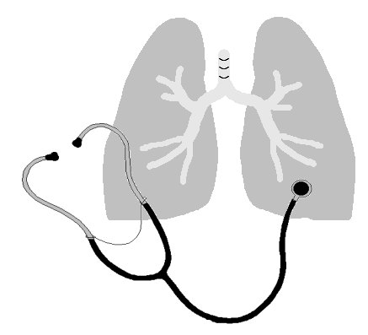

David Panossian, M.D., P.C., DABSM
2614 Almond Street, Klamath Falls, Oregon 97601
(541) 885-2201, FAX (541) 883-1400

AUTHORIZATION TO RELEASE INFORMATION TO FAMILY MEMBERS

Many of our patients allow family member and or others to call and request medical or billing information. Under the requirements of HIPAA we are not allowed to give this information to anyone without the patient’s consent. If you wish to have your medical or billing information released to family members or others you must indicate those individuals below and sign this form giving consent to do so.

You have the right to revoke this consent in writing at any time.

I authorize / allow Klamath Pulmonary & Critical Care Medicine and Klamath Sleep Medicine Center to release my medical and / or billing information to the following individual(s):

- _________________________________________ Relation to Patient ______________________

- _________________________________________ Relation to Patient ______________________

- _________________________________________ Relation to Patient ______________________

Patient Name: ______________________________________________________________________________

Patient Signature: _______________________________________________ Date: ___________________

AUTHORIZATION TO LEAVE MESSAGES WITH HOUSEHOLD MEMBERS / ANSWERING MACHINE:

Occasionally it is necessary for the staff at Klamath Pulmonary & Critical Care Medicine and Klamath Sleep Medicine Center to leave messages for patients. The purpose of these messages is to remind you of your appointment, to notify you that the medical staff would like to discuss or schedule test results, or to ask a patient to call regarding an issue or concern. By signing below you are authorizing us to leave messages with members of your household or on your answering machine.

You have the right to revoke this consent in writing at any time.

Patient Name: ______________________________________________________________________________

Patient Signature: _______________________________________________ Date: ___________________

